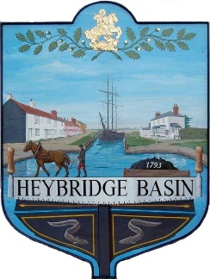

HEYBRIDGE BASIN PARISH COUNCIL
Schedule of meetings 2025/2026

Date | Time | Venue
Tuesday 24th June | 6:30pm | St George’s Community Room
Tuesday 15th July | 6:30pm | St George’s Community Room
Tuesday 9th September | 6:30pm | St George’s Community Room
Tuesday 14th October | 6:30pm | St George’s Community Room
Tuesday 18th November | 6:30pm | St George’s Community Room
Tuesday 16th December | 6:30pm  (If needed) | St George’s Community Room
Tuesday 13th January | 6:30pm | St George’s Community Room
Tuesday 10th February | 6:30pm | St George’s Community Room
Tuesday 17th March | 6:30pm | St George’s Community Room
Tuesday 21st April | 6:30pm | St George’s Community Room
Tuesday 28th April | 6:30pm  (Annual Parish Assembly) | St George’s Community Room
Tuesday 19th May | 6:30pm  (Annual Statutory Meeting) | St George’s Community Room

